NOISE FILTERING

# Aim

Signals are of poor quality and often very noisy. Crying, the first concern because it directly influences breathing, has been removed. However, the noise due to doctors' conversation, heartbeat, stethoscope imprecision and respiratory supports is still present. Although they are independent of breathing, they must be attenuated so that they do not influence the features (cf section 3). This part is very important, but for lack of time, a simple filtering was done. It should be improved afterwards.

According to the paper …[1], the breathing sounds of premature infants are between 100 and 1200Hz. A passband Butterworth filter between these frequencies was then designed.

# Butterworth Filter

## Overview

Butterworth filter is a linear filter with constant gain in its bandwidth. This filter is widely used in engineering as it enables to pass some range of frequencies without distortion and suppress all other frequencies.

The filter order determines the shape and width of the roll-off, also called the “transition band”. In the passband, the gain is close to one. As the frequencies come closer to the cutting frequencies, the gain of the filter rolls off, rejecting lower and higher frequencies components. The way that the curve is shaped depends on the filter order. The higher it is, the shorter the transition will be, as illustrated in figure .. with $n$ the filter order. The order was chosen at 6 to have sufficient selectivity while having a reasonable computation time.

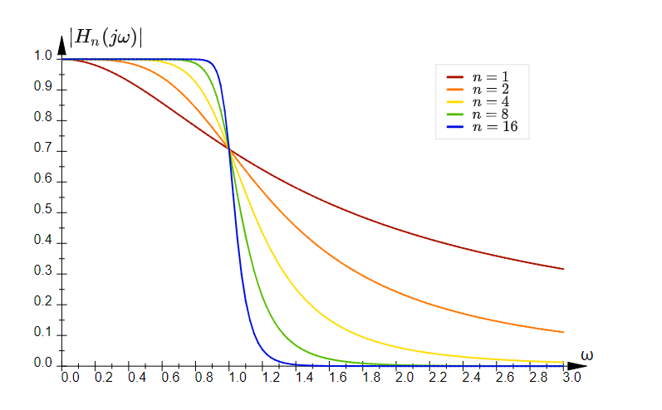

Figure 1: Amplitude responses of Butterworth filters with different orders

Source : [tttapa.github.io](https://tttapa.github.io/Pages/Mathematics/Systems-and-Control-Theory/Analog-Filters/Butterworth-Filters.html)

It is an Infinite Impulse Response (IIR) filter, causal, with the following amplitude response (equation 1).

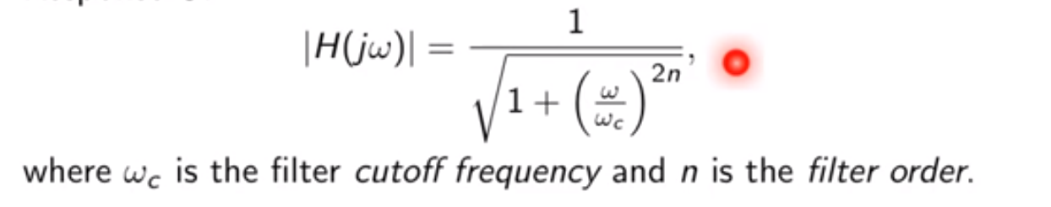

## Analysis of the obtained filter

To design the filter, a sampling frequency of $F_s = 4000$ Hz and cutoffs frequencies of $f_c ^ 1 = 100$ and $f_c ^ 2 = 1200$ Hz were used.

The magnitude response of the filter is in Figure .... It has a gain of 1 (within -3dB) between $0.05pi$ and $0.6pi$ rad/sample, which corresponds to the cutoffs frequencies of 100Hz and 1200Hz after the following conversion:

$f_c^{Hz}=\frac{f_c^{rad/samp}}{2pi}*f_s$

Figure 2 shows the phase response of the filter. It is not linear, which implies that the frequency components will not all be delayed in the same way. In our case, this is not a problem because all the signals will experience the same delay, which will not influence the results during their comparison. The expression of the phase delay is in equation 1, and that of the group delay in equation 2. Since the phase is non-linear, the group delay (in Figure 3) is not constant. This delay corresponds to the time taken by the energy of the signal to cross the filter. For the same reason, this delay does not matter in the project.

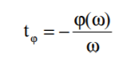equation 1

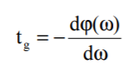equation 2

The poles and zeros of the filter are in Figure .... Two zeros are located on the unit circle corresponding to two total rejections. They are in $F_s$ and $\frac{F_s}{ 2}$. The Butterworth filter poles, for their part, are at the number of $2n$ with $n$ the filter order. These 12 poles are situated inside the unit circle, meaning that the filter is stable. Their module decreases when the frequencies are closer to the rejection frequencies, which is equivalent in the response magnitude to the transition bands.

Mettre légende cross poles et rond zeros

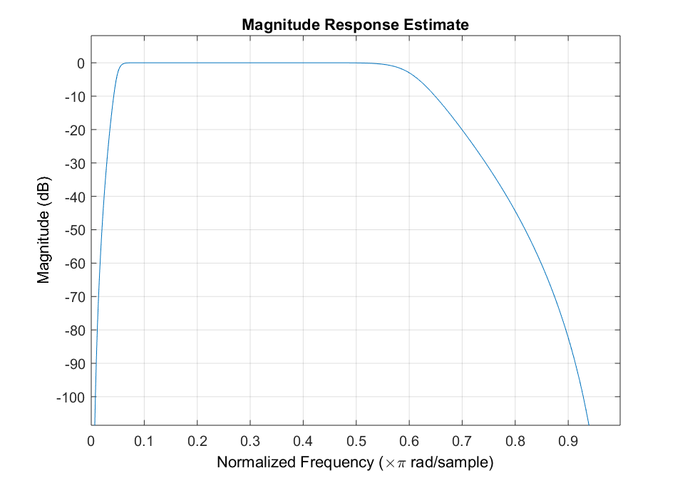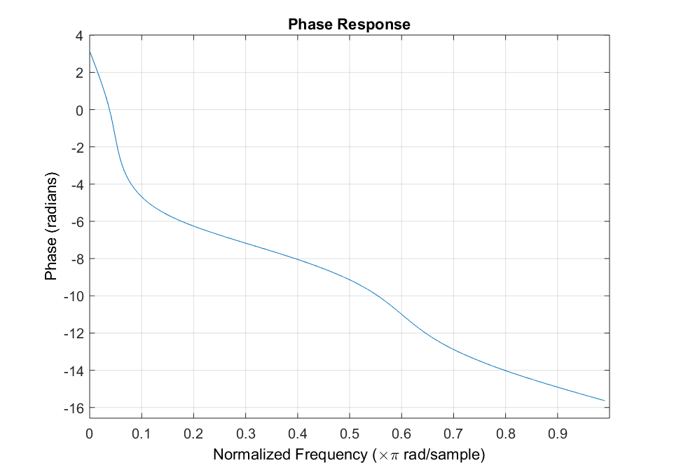

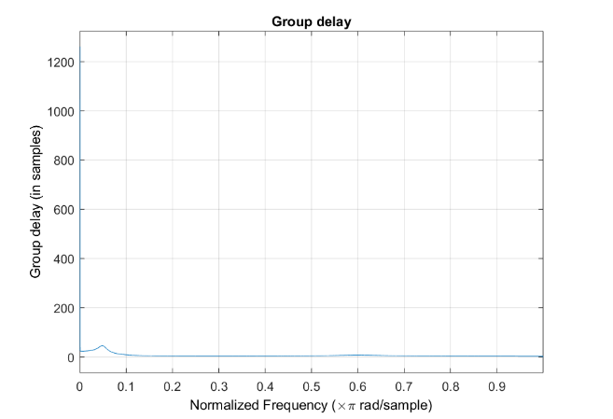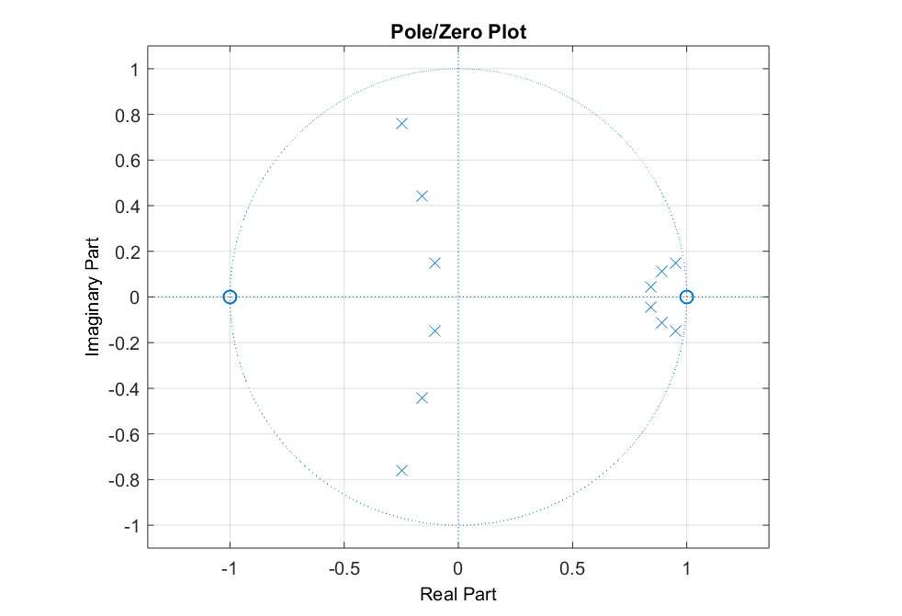

Figure 2: Magnitude, phase response, group delay and poles and zeros of the Butterworth Filter

# Results

This filter has allowed to keep the signal frequencies between 100 and 1200Hz, without deformation. Figure ... shows the periodogram of the signal before and after the passage of the filter.

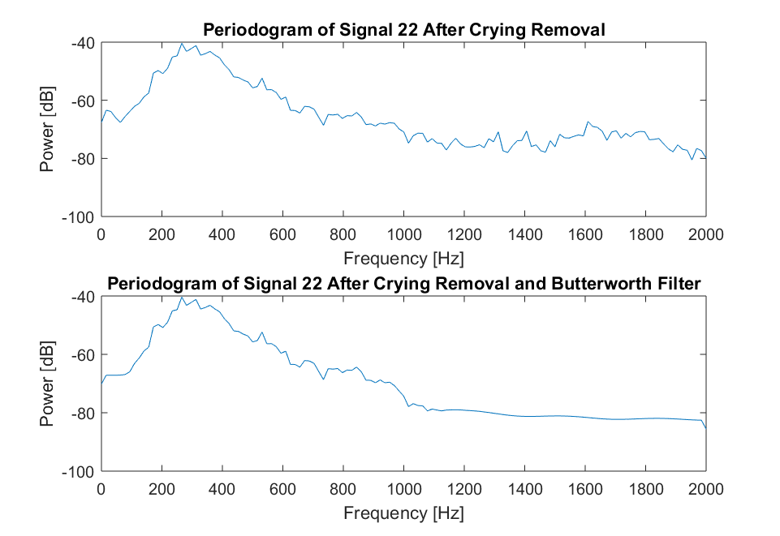

Figure : Periodogramme du Signal 22 avant et aprés filtrage par le Butterworth filter

# Discussion

Filtering was the fastest method, but listening to filtered signals, noise attenuation could be further improved.

In the paper ... (Peruvians), they excluded segments judged as either non-informative or contaminated with noises. However, we decided to avoid exclusion because it generates discontinuities in the signal. Some are already present as the result of crying removal and it was judged that adding more could influence the analysis, in particular due to the frequency peaks that they cause.

Future improvements will certainly be achieved through statistical techniques based on independence between noises and breathing. The single-channel blind signal separation (SCBSS) method, for example, enables to extract distinct streams of information from a single mixed signal.

Some noises were also not taken into account, such as the noise made by the respiratory supports. Bubble and CPAP sounds are very present in some recordings and will also have to be mitigated.

DEMANDER DAVOOD COMMENT IL FAIT ?

1. Comparison of the Lung Sound Frequency Spectra of Infants and Adults

   Jamshed F., et. al.

   1986 Pediatr Pulmonol 1986; 2:292-295